A REPORT

ON

Delivery Route Optimization using Ant Colony Optimization (ACO)

By

Name of the Student Registration No.
Sai Prasanth AP24110011854
Karthikeya AP24110011865
Surendra AP24110011891
Jagadeesh AP24110011887

Prepared in the partial fulfillment of the
Project Based Learning of Course CSE 204 – Design and Analysis of Algorithms



SRM UNIVERSITY, AP

NOVEMBER 2025

CERTIFICATE

This is to certify that the project entitled Delivery Route Optimization using Ant Colony Optimization (ACO) has been successfully completed by Sai Prasanth (Roll Number: AP24110011854) as a required academic component of the course CSE 204: Design and Analysis of Algorithms during Semester 3 of Academic Year 2025-26 in the Department of Computer Science and Engineering at SRM University, AP. This work was executed under the guidance of the undersigned and is deemed to have successfully met all course requirements as of date.

(Signature of the Course Instructor)

Krishna Kumari M,
Assistant Professor, Department of Computer Science and Engineering SRM University, AP
1.) Introduction:
In logistics and transportation systems, selecting the optimal delivery route plays a crucial role in reducing travel time, fuel consumption, and operational cost. Delivery services such as e-commerce companies, courier systems, food delivery, and supply chain networks are highly dependent on efficient route planning.
The Delivery Route Optimization problem can be mapped to the well-known Travelling Salesman Problem (TSP), where a delivery agent must start from a source, visit all required locations exactly once, and return to the base or destination with the minimum possible distance or cost.
To solve this, several optimization techniques exist, but classical methods become inefficient as the number of delivery points increases. Ant Colony Optimization (ACO), inspired by the foraging behaviour of ants, provides a powerful meta-heuristic for efficiently finding near-optimal paths in such complex spaces.
2.) Problem Description:
The goal of this project is to determine the shortest and most efficient delivery route starting from a source location and covering multiple delivery destinations.
Problem characteristics:
- Given a set of N delivery locations.
- A delivery agent starts from source point A.
- The paths between any two locations have associated distances.
- The objective is to find the shortest possible tour that visits all destinations exactly once.
This is equivalent to the Traveling Salesman Problem (TSP), which is NP-hard.
Therefore, exact algorithms are computationally expensive for large datasets.
This project adopts Ant Colony Optimization (ACO) for constructing high-quality solutions efficiently.
3.) Proposed Solution:
a.) Why ACO?
- Inspired by how ants find shortest paths using pheromones.
- Good at solving combinatorial optimization problems like TSP.
- Produces near-optimal results efficiently.
- Dynamic adjustment of pheromone trails helps converge to the best route.
b.) Algorithm
Input:
Graph with distances dist[i][j] for all cities i, j
Number of ants = m
Number of iterations = max_iter
α = pheromone importance
β = heuristic importance
ρ = pheromone evaporation rate
Q = pheromone deposit constant

Output:
Best tour found and its cost
Initialize pheromone τ[i][j] = constant value for all edges
For each i, j compute heuristic η[i][j] = 1 / dist[i][j]

bestTour ← empty
bestCost ← ∞

For iter = 1 to max_iter do:

For each ant k = 1 to m do:

// --- Construct a tour ---
Choose a random starting city for ant k
Mark starting city as visited
tour[k] ← [start]

While tour not complete:
Let current = last city in tour
For each unvisited city j:
Compute probability:
P[current][j] = (τ[current][j]^α) * (η[current][j]^β)
Normalize probabilities
Select next city based on probability distribution
Append selected city to tour
Mark city as visited

Compute cost of tour[k]

If cost < bestCost:
bestCost ← cost
bestTour ← tour[k]

// --- Update pheromones ---
For all edges (i, j):
τ[i][j] = (1 - ρ) * τ[i][j] // evaporate pheromone

For each ant k = 1 to m:
For each edge (i, j) in its tour:
τ[i][j] = τ[i][j] + Q / cost_of(tour[k])

End For

Return bestTour, bestCost
c.) Advantages of ACO
- Fast convergence
- Works even for large datasets
- Good balance between exploration & exploitation
- Naturally fits delivery and logistics planning
4.) Application / Adoption:
This project fits real-world delivery systems such as:
- E-commerce delivery (Amazon, Flipkart)
- Courier services
- Food delivery routes (Swiggy, Zomato)
- Postal services
- Warehouse-to-customer shipping
- Last-mile delivery optimization
Companies can adopt ACO for:
- Reducing fuel usage
- Minimizing delivery time
- Planning daily distribution routes
- Automated route scheduling in dispatch systems
5.) Experiments and Results:
Dataset
- Coordinates of delivery locations were given as input.
- Distances between all points were computed using Euclidean formula.
Implementation
- ACO algorithm implemented in c language.
- Visualization created to show:
  - General paths (dark red)
  - Best path (dark green)
- Visuals can see using this website:
http://127.0.0.1:5500/ACO.html
Observations
- Initial iterations produced random routes.
- Over time, pheromone concentrated on shorter routes.
- Convergence achieved within 20–50 iterations depending on dataset size.
- The best path length reduced significantly compared to random traversal.

Final Output
- The ACO algorithm successfully identified an optimal delivery route.
- The shortest path discovered after convergence was displayed prominently in dark green.
- All alternative or non-optimal routes explored by the ants during the search process were displayed in dark red, helping visualize how pheromone-guided learning improved route selection.
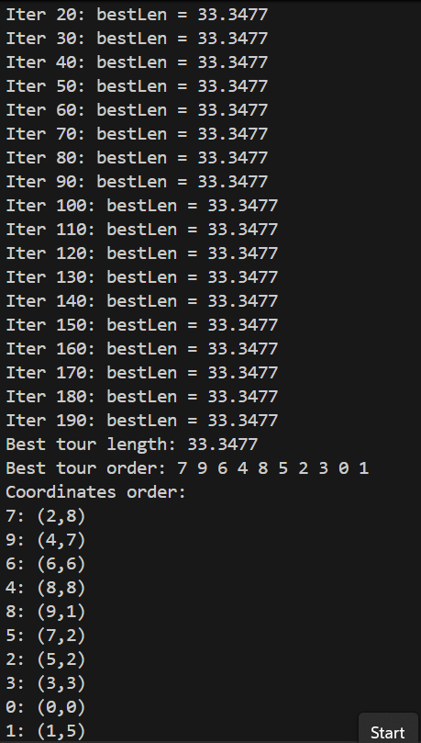

6.) Conclusion:
The Ant Colony Optimization algorithm successfully optimized the delivery route, providing a near-optimal path in a reasonable computation time. The behaviour of ants selecting shortest routes was effectively translated into a powerful optimization strategy for real-world delivery systems.
The project demonstrates that ACO is well-suited for:
- Large-scale delivery networks
- Dynamic route optimization
- Real-time logistics decision-making
This method helps reduce travel cost, operation time, and overall delivery complexity.

